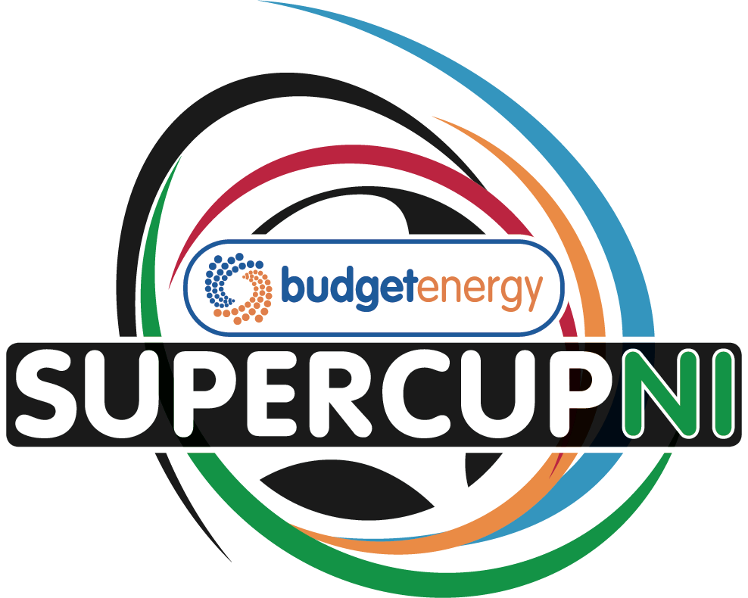
Budget Energy SuperCupNI 2026 (Sunday 26th July to Friday 31st July
APPLICATION FORM – BOYS’ TOURNAMENT
Team name
Contact name
Address and post code
Contact number
Email

Age Group: Mark X as appropriate based on section applying for
Minor
(Players born on or after 1st January 2013)
Junior
(Players born on or after 1st January 2012)
Premier
(Players born on or after 1st January 2010)

Number of players per team | Number of officials (staff/coaches) per team

On behalf of the above-named team(s), I hereby apply for entry to the Budget Energy SuperCupNI and if accepted will abide by the Tournament Regulations.

Signed: Date:

CLOSING DATES FOR APPLICATION - Friday 31st October 2025

Please complete this form and email to samgamble@supercupni.com

The Entry Fee (£200 per entry/team) can be paid by electronic bank transfer and sent to Danske Bank
Sort Code 95-02-77 Swift Code: DABAGB2B
Account Number: 11305093 IBAN: GB93 DABA 9502 7711 3050 93
Account Name: The Northern Ireland International Youth Football Cup Limited
PLEASE ADD YOUR TEAM NAME TO THE PAYMENT FOR REFERENCE

