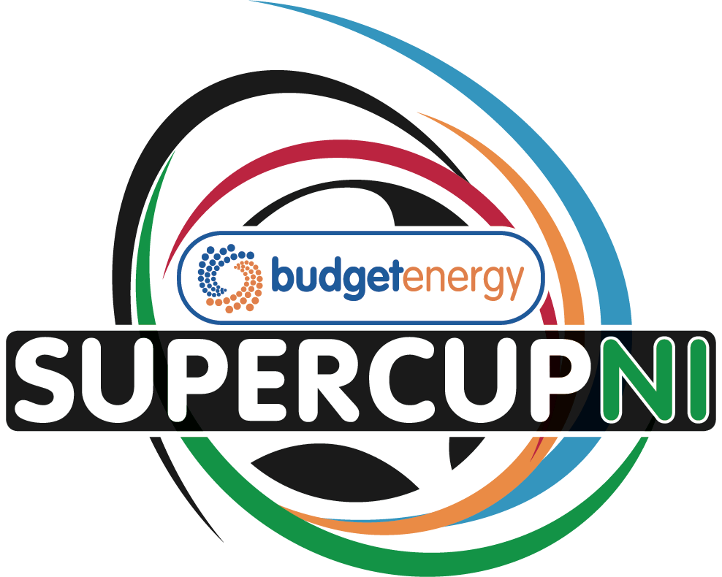
Budget Energy SuperCupNI 2026 (Sunday 26th July to Thursday 30th July)
APPLICATION FORM – GIRLS’ TOURNAMENT
Team name
Contact name
Address and post code
Contact number
Email

Age Group: Mark X as appropriate based on section applying for
Junior
(Players born on or after 1st January 2012)
Premier
(Players born on or after 1st January 2010)

Number of players per team | Number of officials (staff/coaches) per team

On behalf of the above-named team(s), I hereby apply for entry to the Budget Energy SuperCupNI and if accepted will abide by the Tournament Regulations.

Signed: Date:

CLOSING DATES FOR APPLICATION – Monday 1st December 2025

Please complete this form and email to alfiewylie@supercupni.com

The Entry Fee (£200 per entry/team) can be paid by electronic bank transfer and sent to Danske Bank
Sort Code 95-02-77 Swift Code: DABAGB2B
Account Number: 11305093 IBAN: GB93 DABA 9502 7711 3050 93
Account Name: The Northern Ireland International Youth Football Cup Limited

PLEASE ADD YOUR TEAM NAME TO THE PAYMENT FOR REFERENCE

